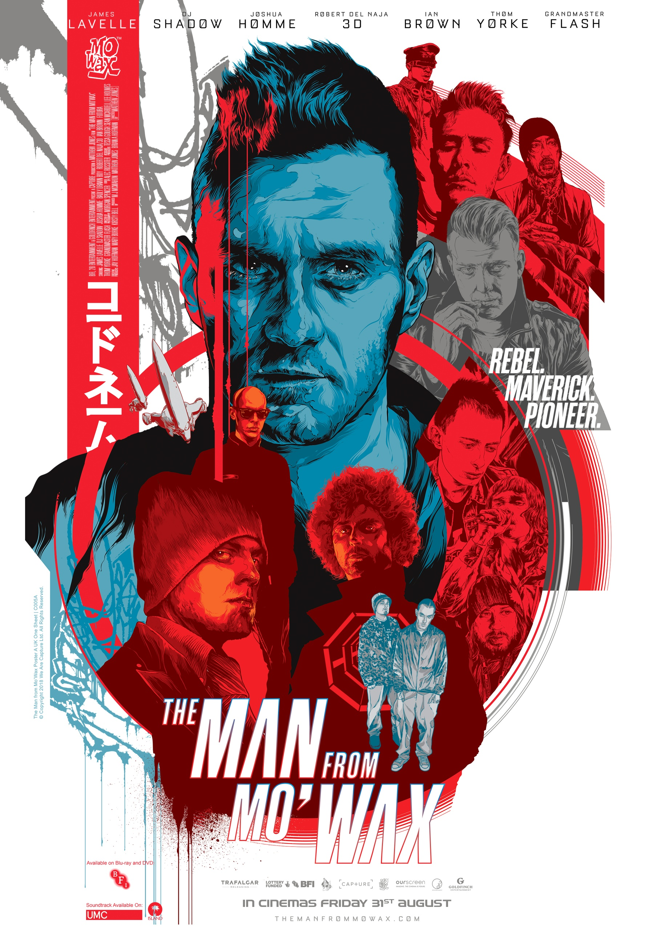

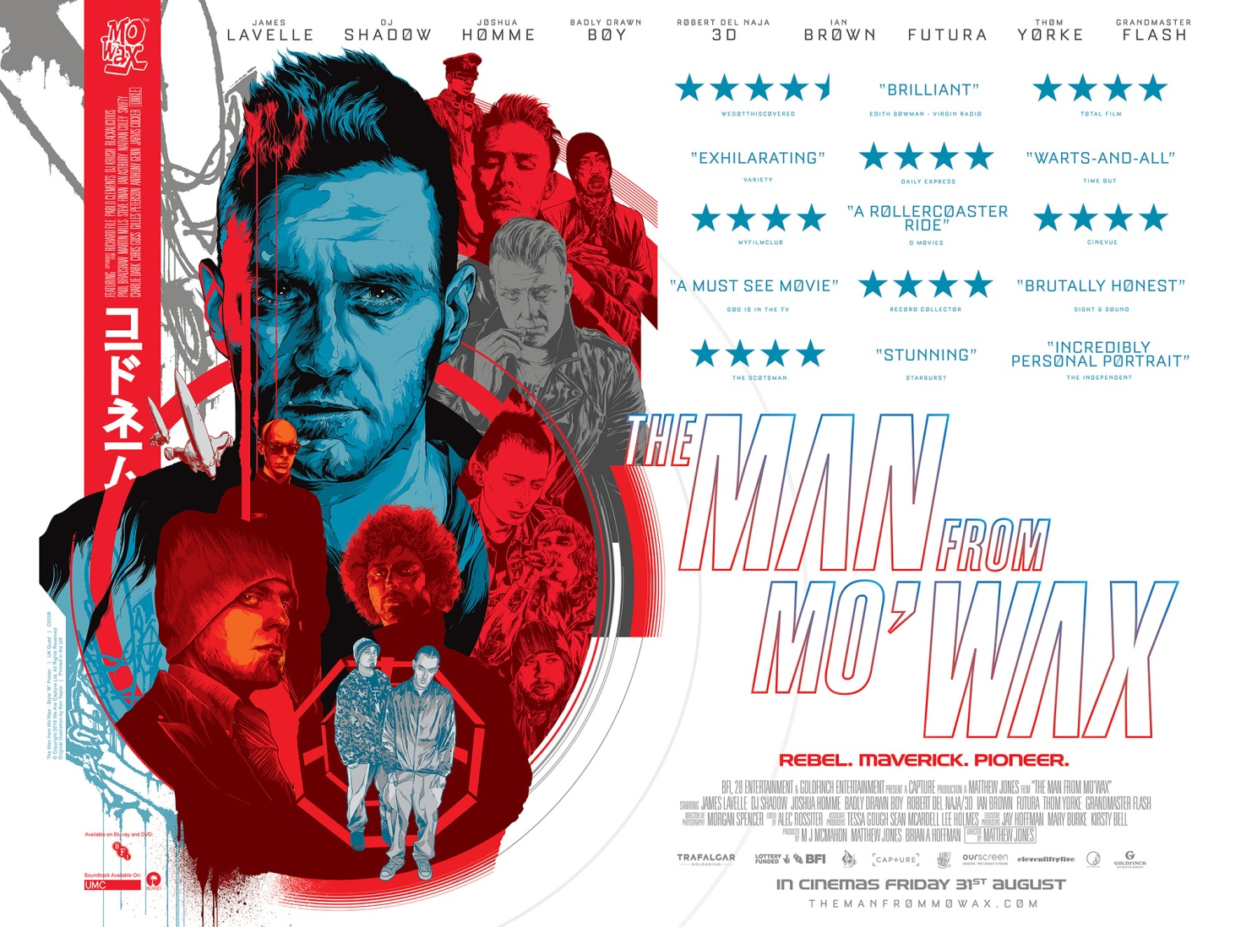

TITLE  DIRECTOR  PRODUCERS  PRODUCTION COMPANY  PRESENTED BY  RUNNING TIME  WEBSITE  FACEBOOK  INSTAGRAM  PRESS CONTACT  SALES | The Man from Mo'Wax  Matthew Jones  M.J. McMahon, Matthew Jones & Brian A. Hoffman  Capture  28 Entertainment, Goldfinch Entertainment & BFI  109 minutes  www.themanfrommowax.com  www.facebook.com/TheManFromMoWax  www.instagram.com/themanfrommowax  all@wearecapture.com  Special Treats represent TV sales, any inquires please contact Andrew Winter (andrew@specialtreats.co.uk) or Louise Brookes (louise@specialtreats.co.uk)  tel:+44(0)2078511111 http://specialtreats.co.uk/

A pulsating documentary charting the extraordinary life and career of underground DJ icon, music producer and global trip hop mogul, James Lavelle. Starring DJ Shadow, 3D of Massive Attack, Futura, Ian Brown, Grandmaster Flash and Joshua Homme.

James Lavelle played his first DJ set at 14, launched pioneering record label Mo'Wax at 18 and released the genre defining UNKLE album Psyence Fiction at 22. His phenomenally rapid rise seemed limitless, but it's only when you're going so fast that the wheels fall off.

The Man from Mo’Wax tells the remarkable story of one of the most enigmatic yet influential figures in contemporary British culture. Unearthed from over 700 hours of footage including exclusive personal archive spanning three decades, we get the rare opportunity to watch a boy become a man in the world of music.

The result is an exhilarating, no holds-barred ride into the life of an extraordinary man and an equally extraordinary era, taking in some decidedly flawed decision-making (both personal and professional), Lavelle emerges as an innovative artist who thinks big and consistently overcomes adversity.

A documentary feature film about DJ, and music industry icon; James Lavelle. The Man from Mo'Wax is set across three decades of industry flux as a teenage boy’s wildest dreams collide with his greatest friendships in a quest for musical super-stardom. An incredible, tempestuous and acrimonious life and career will play out before our eyes as success’ come & go, aspirations crumble, friendships collapse and a boy who won't grow up is forced to come to terms with his biggest mistakes across a 25 year period.

The film explores the nature of musical success and the trials and tribulations that come with it. With never before seen personal archive and exclusive home video footage from both James Lavelle & DJ Shadow, and distilled down from nearly 700 hours of footage; witness Lavelle’s extraordinary experience and whirlwind professional journey of personal highs and lows. Breaking down boundaries with the setup of his world renowned, genre defining trip-hop record label Mo'Wax, becoming a millionaire by the age of 21, and forming the super band UNKLE with the likes of DJ Shadow, Thom Yorke, Ian Brown, Joshua Homme and Richard Ashcroft.

Battling the constant struggle of art vs commerce, James emerges from his A&R roots as an artist in his own right, but has the price he’s paid been worth it?

The Man from Mo'Wax is a film about the price of musical success.
I wanted to tell a human story about the excesses of the 90’s music scene and the long term effects of a DJ lifestyle, whilst also making a film which was really positive, uplifting and championed the go-getter, anything-is-possible philosophy of James Lavelle. James’s bulldog approach to pursuing his dreams and brushing people aside in his relentless quest was always what drove my ideas around the structure of the film. I set out to make a fast, rollicking entertainment piece, echoing James’s insatiable drive, whilst concentrating on the human ramifications on his life and career, to offer a poignant insight into a life that many desire but few know the reality of. The ultimate goal was to give the audience something a lot more reflective and contemplative than a simple A to B Wikipedia-like entry.
I always intended the rise of James through the various milestones of launching Mo’Wax, releasing DJ Shadow’s Endtroducing… record, pioneering Trip-Hop and the early days of UNKLE to be a 100mph rip roaring rock n roll ride through his teens and 20’s, putting the audience in the whirlwind seat of James himself and whizzing them up to the top of the summit so they can see the fall that awaits them at the top.
Access to real life footage in documentary filmmaking is something you cannot fake and due to the unprecedented openness we were granted by James Lavelle – filming his life and being given his personal home video & photography archive, this film takes on a much more personal side to your typical music documentary. I will be forever grateful to both James and DJ Shadow for the candid, never-before-seen window into their lives, and that the both of them were generous enough to entrust me with their intimate recorded memories.
A huge part of this film has been following the rabbit hole down to unearth the treasure of lost archive footage. Through 3 years of intensive digging, we found footage in parent’s lofts and forgotten interviews that broadcasters had never even shown before. In total, this movie has been sifted down from nearly 700 hours of material and almost every format of film and video is represented within the film. From the time we first picked up a camera to the world première, it will have been a 10 year process to get this film on screen, and I wouldn’t have it any other way. Over that time we got a true glimpse into a unique individual’s existence. James’s life from 14 to 40, and all the highs and lows in between, are all there - condensed into 2 hours. James’s career has been built on him working with numerous high profile individuals and no film about him would be complete without their contributions. I wanted those friends and colleagues to help narrate James’ personal struggles and hardships, alongside his biggest successes.
I‘d love for people to walk out of the cinema inspired, with a little of James’s wild crazy dreamer side having rubbed off on them. I hope people will see that what really matters in life are your friends, and that whilst striving for creative perfection is a wonderful pursuit, it’s often immensely challenging to find the right balance between chasing a dream that’s larger than life and maintaining the long term relationships that really matter.

MATTHEW JONES // DIRECTOR & PRODUCER
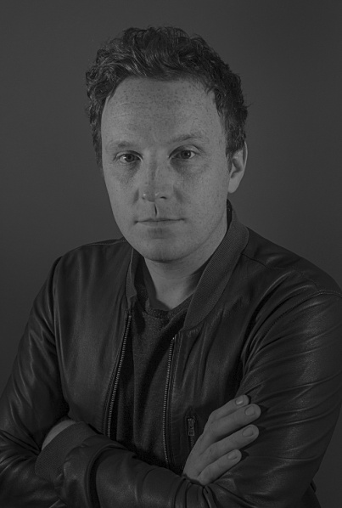
Matthew Jones is a multi-award winning creative Director and Producer from London. In 2009 he co-founded the production company Capture, directing and producing commercials for television and cinema as well as promos and cutting edge digital interactive content for companies like Sky, Nike, Jameson, the ICA and Picturehouse Cinemas.

A first time feature film director, Matthew has previously produced the award winning epic short film Hawk, which was theatrically released in selected cinemas in Wales in front of Harry Potter & The Deathly Hallows: Part 2. It was also nominated for Best International Short Film at I've Seen Films International Film Festival. His second short film, the multi award winning Gin & Dry was funded by Film London through their Borough Funds scheme and was nominated/officially selected for over 13 international film festivals. In addition Gin & Dry secured a nationwide UK theatrical release with Picturehouse Cinemas across 10 sites, appearing over 100 times in front of features such as Gods & Men, The American, and It's a Wonderful Life.

The Girl in The Dress, starring Olivia Poulet and Nick Helm, marked Matt's third short film as producer and premièred at The BFI Film Festival 2015, as well as making the official selection for the London Short Film Festival 2016. The film was funded by Film London, Creative Skillset and the BFI. This was quickly followed by his fourth short film Killing Thyme, starring Brian Cox and Charlotte Riley, which was nominated for Best Comedy at the 2015 Aesthetica Short Film Festival, was an Official Selection at Foyle Film Festival, and then went on to win Best Comedy and Best of Festival at Carmarthen Bay Film Festival. His first feature film, a music documentary called The Man from Mo'Wax is currently in festivals after world premiering at SXSW in 2016.
IMDb

M J McMAHON // PRODUCER

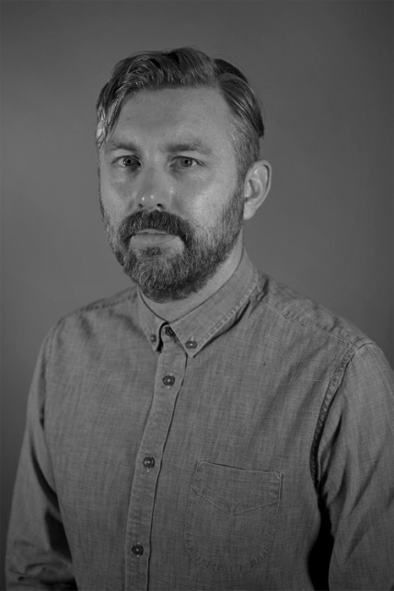
McMahon is based in London, UK, and has worked professionally in the Film and TV industry for over 16 years, originally starting as a runner for post-production company M2 Television and eventually moving across to Molinare finishing his 9 year tenure there as one of their senior Post-Production Consultants. He has extensive knowledge and experience working in digital post-production working on over 200 productions including TV shows Who Do You Think You Are?, Wife Swap, to feature films like The Nine Muses, associate producing Cherry Tree Lane and as Film Executive on Oscar winner The King’s Speech.

In 2009 he co-founded the production company Capture, they produce commercials, online content and promos for clients including Nike, ITV, Ogilvy, AKQA, BBC and Sky TV. Through their Film Division he’s produced The Man from Mo’Wax – the official documentary on underground DJ James Lavelle and DJ Shadow, this world premiered at SXSW and was officially selected for MIFF and LFF. In addition to this he produced the multi-award winning short film Gin & Dry followed by The Girl in The Dress.

As a director he made the multi-award winning short films Hawk and Killing Thyme which stars Scottish actor Brian Cox and Charlotte Riley, this won the Audience Award for Best Narrative Short Film at this year’s Austin Film Festival making a tally of over 50 wins/nominations/official selections for his films at festivals around the world. He’s presently developing his directorial feature film debut Playing Mercy.

McMahon has been a BAFTA member since 2003.
IMDb

BRIAN A. HOFFMAN // PRODUCER
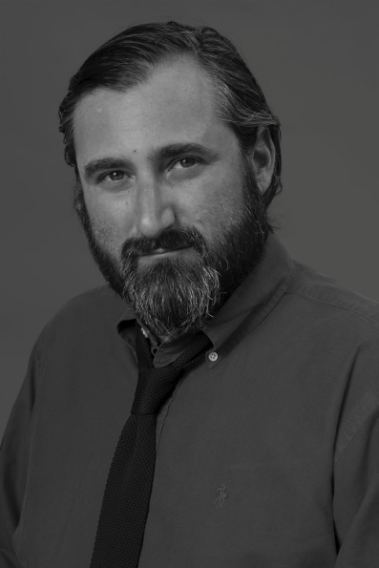
Brian began his career in the film business in 2002, starting out in the development departments of Working Title Films and Escape Artists and then on to feature post-production at 20th Century Fox. Over the span of his career Brian has also had the opportunity to work in various capacities on the Academy Award winners Sideways and Ray; along with other notable films, such as Taken, Asylum, and Eragon. He then went on to produce the award-winning cult-classic, corked! as well as the dramatic and uplifting, Deep In The Heart.

As a producer, Brian believes in strong development and has several exciting projects in the pipeline. Brian is also an active screenwriter and member of the WGAW. His latest project, The Man from Mo'Wax, is a collaboration with Capture in London, and had its world première as an official selection at South By Southwest 2016.
IMDb

ALEC ROSSITER // EDITOR

Editor of feature music documentary The Man from Mo'Wax, Alec Rossiter has over a decade of experience editing films and television programmes. Alec is also a screenwriter: "Editing and screenwriting, although at opposite ends of the production process, have much in common: The craft of storytelling.
Alec has worked across drama, documentary and commercials - he has a production company Speaking Pictures that also has its own film projects in development. Alec started his career as a graduate of Westminster Film School, a leading UK film production course with alumni such as Oscar winning Asif Kapadia.
IMDb

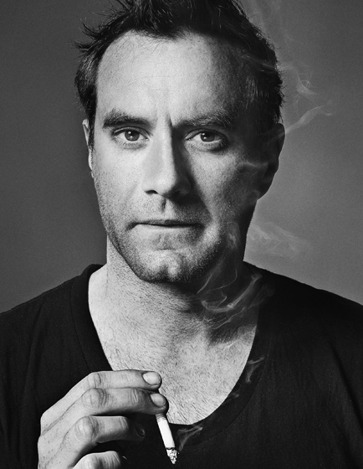
JAMES LAVELLE

James Lavelle is an English electronic musician and pioneering trip hop record label boss whose foray into the music world started at age 14. Inspired by the sound systems put together by the likes of Afrika Bambaataa in the US and The Wild Bunch over in Bristol, James started buying records by the bucket load and providing the soundtracks to his home town Oxford's own block party scene. The first party he put on, at 15, made him enough money to get a pair of decks and with Oxford starting to run out of vinyl, London beckoned.

At 18, Lavelle was working at Honest Jon’s Records as well as writing his own column, Mo' Wax Please, for music magazine Straight No Chaser, and in the midst of it all, he decided to open his own music label and Mo’Wax was born. The label soon became known for it’s unique sound, dubbed ‘Trip Hop’ and in 1996 Mo'Wax released one of electronic music's most celebrated albums, DJ Shadow's seminal Endtroducing.... Soon after, Lavelle started work on an album with DJ Shadow under the name UNKLE. The resulting release Psyence Fiction featured collaborations with Richard Ashcroft, Mike D, Badly Drawn Boy and Thom Yorke. Since then, UNKLE has taken on many different iterations, with Lavelle collaborating with a rich variety of musicians, each providing a new and unique sound for the musical outfit.
Lavelle has also done a lot of TV and film score work, including scoring director Jonathan Glazer’s Sexy Beast, as well as contributing tracks to the X-Files and Twilight. As a DJ, he has remained in-demand on local and global scales. He put together several commercially released DJ sets, including the first volume of FabricLive (2001) and several instalments for Global Underground (2002-2015).

DJ SHADOW

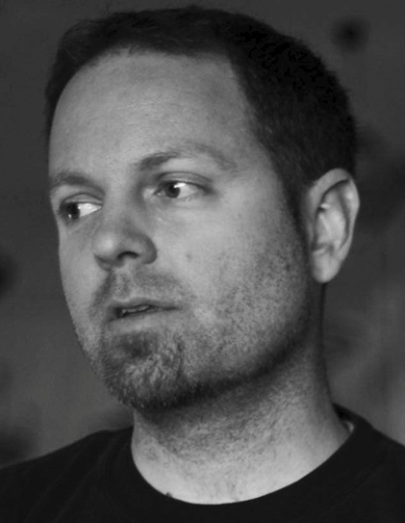
Josh Davis grew up in Hayward, CA, a predominantly lower-middle-class suburb of San Francisco. The odd White suburban hip-hop fan in the hard rock-dominated early '80s, Davis gravitated toward the turntable/mixer setup of the hip-hop DJ over the guitars, bass, and drums of his peers. He worked his way through hip-hop's early years into the heyday of crews like Eric B. & Rakim, Ultramagnetic, and Public Enemy; groups which prominently featured DJs in their ranks. Davis had already been fiddling around with making beats and breaks on a four-track while he was in high school, but it was his move to the NorCal cow-town of Davis to attend university that led to the establishment of his own Solesides label as an outlet for his original tracks. Hooking up with Davis' few b-boys (including eventual Solesides artists Blackalicious and Lyrics Born) through the college radio station, Shadow began releasing the Reconstructed From the Ground Up mix tapes in 1991 and pressed his 17-minute hip-hop symphony "Entropy" in 1993. His tracks spread widely through the DJ-strong hip-hop underground, eventually catching the attention of Mo' Wax. Shadow's first full-length, Endtroducing..., was released in late 1996 to immense critical acclaim in Britain and America. Pre emptive Strike, a compilation of early singles, followed in early 1998.
Later that year, Shadow produced tracks for the debut album by UNKLE, a long-time Mo' Wax production team that gained superstar guests including Thom Yorke (of Radiohead), Richard Ashcroft (of the Verve), Mike D (of the Beastie Boys), and others. His next project came in 1999, with the transformation of Solesides into a new label, Quannum Projects. Nearly six years after his debut production album, the proper follow-up, The Private Press, was released in June 2002. Since then, Shadow has released four more albums and in 2014, he launched his new record label imprint Liquid Amber. His latest album, The Mountain Will Fall, was released in summer 2016.

Director: MATTHEW JONES

Executive Producers: JAY HOFFMAN, MARY BURKE, KIRSTY BELL

Producers: M J McMAHON, BRIAN A. HOFFMAN, MATTHEW JONES

Associate Producers: TESSA GOUGH, LEE HOLMES, SEAN McARDELL

Editor: ALEC ROSSITER

Cinematographer: MORGAN SPENCER

Cinematographer – L.A. Unit – MIGUEL MEDINA

Archive Researcher: TALISA OBEROI

Archive Researcher: HENRIETTA LEE

Studio RM Head of Film: FAWNDA DENHAM

Colourist: JAMIE NOBLE

Sound FX Editor: TOM FOSTER

Dialogue Editor: CLAIRE ELLIS

Additional Music and Sound Design: LIAM PATON

Sound Post Production Manager: SEAN McMORRIS

Sound Re-recording Mixer: GEORGE FOULGHAM

Additional Sound Re-recording Mixer: NAS PARKISH

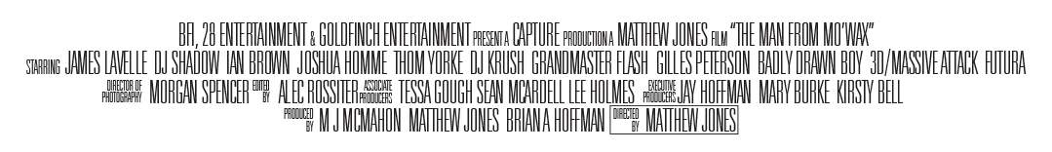

Available on request:

